* **Bootstrap Basic & Advance**

• What are the advantages of Bootstrap?

* Top 10 Advantages of Bootstrap for Web Development:
* Easy initiation. Coding is a hurricane task for a person who is unbeknownst to web development. ...
* Responsiveness. ...
* Highly customizable. ...
* Extremely user-centric. ...
* Top-notch support. ...
* Cross-browser compatibility. ...
* JavaScript plugins to your rescue. ...
* Far-reaching popularity.

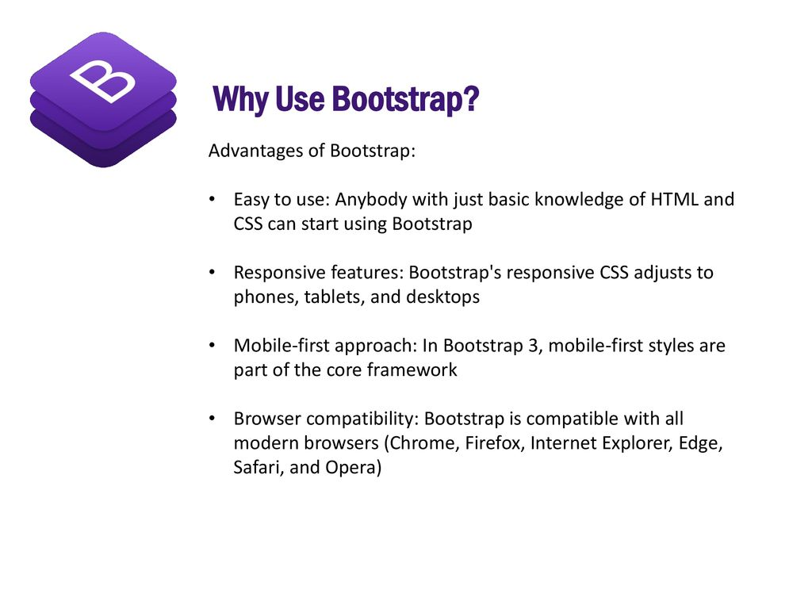• What is a Bootstrap Container, and how does it work?

* Containers are the most basic layout element in Bootstrap and are required when using our default grid system. Containers are used to contain, pad, and (sometimes) center the content within them. While containers can be nested, most layouts do not require a nested container.

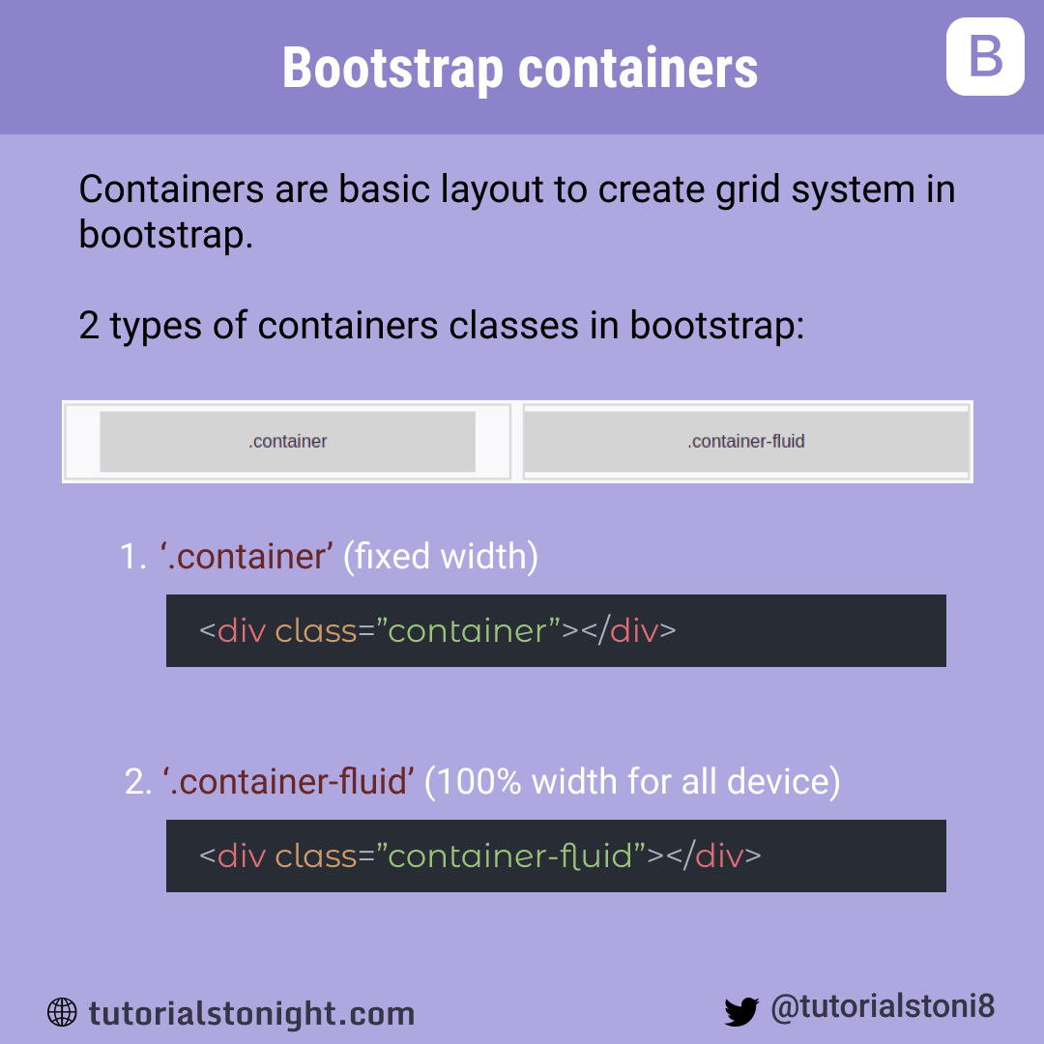

• What are the default Bootstrap text settings?

* Bootstrap 4 Default Settings:
* Bootstrap 4 uses a default font-size of 16px, and its line-height is 1.5. The default font-family is "Helvetica Neue", Helvetica, Arial, sans-serif. In addition, all <p> elements have margin-top: 0 and margin-bottom: 1rem (16px by default).

• What do you know about the Bootstrap Grid System?

* Bootstrap's grid system uses a series of containers, rows, and columns to layout and align content. It's built with flexbox and is fully responsive. Below is an example and an in-depth look at how the grid comes together.

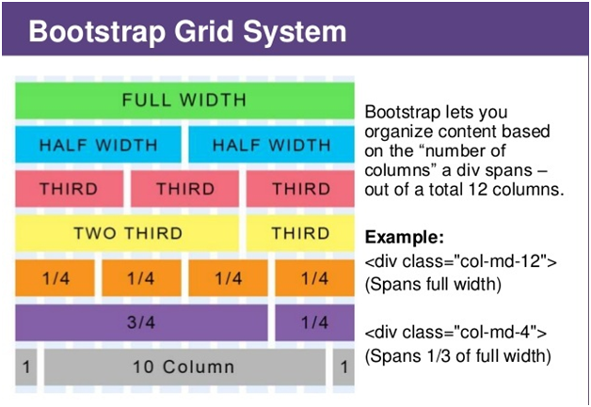

• What is the difference between Bootstrap 4 and Bootstrap 5 ?

**Difference between Bootstrap 4 and Bootstrap 5**

| BASIS OF | BOOTSTRAP 4 | BOOTSTRAP 5 |
| --- | --- | --- |
| **Grid System** | It has 5 tier (xs, sm, md, lg, xl). | It has 6 tier (xs, sm, md, lg, xl, xxl). |
| **Color** | It has limited colors. | Extra colors added with the looks, A card improved color palette. there are various shades available to choose. |
| **Jquery** | It has jquery and all related plugins. | Jquery is removed and switched to vanilla JS with some working plugins |
| **Internet Explorer** | Bootstrap 4 supports both IE 10 and 11. | Bootstrap 5 doesn’t support IE 10 and 11. |
| **Form elements** | Radio buttons, checkboxes have different look in different OS and browsers. The form uses whatever default browsers provide. | The look of form elements will not change, on different OS or browser. The forms can be customized and form controls can be added, they would not depend on browser. |
| **Utilities API** | We cannot modify utilities in bootstrap 4 | Bootstrap 5 gave freedom to modify and also create our own utility |
| **Gutter** | We use .glutter with fontsize in px | We use .g* with fontsize in rem |
| **Vertical Classes** | Columns can be positioned relative | Columns cannot be positioned relative |
| **Bootstrap Icons** | Bootstrap 4 doesn’t have its own SVG icons, we have to use font-awesome for icons. | Bootstrap 5 have its own SVG icons |
| **Jumbotron** | It supports. | It doesn’t support jumbotron. |
| **Card deck** | The card deck is used to create a set of cards with equal width and height. | Card deck class in removed in bootstrap |
| **Navbar** | We have inline-block property and we will get white dropdown as default for dropdown-menu-dark class. | Inline-block property is removed and we will get black dropdown as default for dropdown-menu-dark class. |
| **Static Site Generator** | Bootstrap 4 uses Jekyll software. | Bootstrap 5 uses Hugo software as it is fast static site generator. |
| **flexbox grid** | this makes easier to implement vertical designs, and the columns and rows can easily be implemented. the classes justify-center-content can directly be used to align according to the requirement. | advanced grid system is made available , also columns don’t have relative positions. |
| **RTL Support** | It does not enable RTL(Right to Left) switching. | It enables RTL(Right to Left) switching. |
| **Offcanvas Component** | It does not support Offcanvas Component. | It supports Offcanvas Component(that is it is available now). |

• What is a Button Group, and what is the class for a basic Button Group?

* “Button Groups” in Bootstrap is a class of name “btn-group” which is used to create series of buttons in groups (without spaces) vertically or horizontally. This is the basic syntax of the button group class where each button has its own class of “btn”.

• How can you use Bootstrap to make thumbnails?

* Step 1: Include Bootstrap and jQuery CDN into the <head> tag before all other stylesheets to load our CSS. Step 2: Add <div> tag in the HTML body with class row. In that <div> create four div sections to create four images.

Step 3: Add “col-sm-6” and “col-md-3” to four div sections which creates webpage responsive.

• In Bootstrap 4, what is flexbox?

* Flexbox. The biggest difference between Bootstrap 3 and Bootstrap 4 is that Bootstrap 4 now uses flexbox, instead of floats, to handle the layout. The Flexible Box Layout Module, makes it easier to design flexible responsive layout structure without using float or positioning.

• How can one create an alert in Bootstrap?

* Bootstrap provides an easy way to create predefined alert messages: × Success! This alert box indicates a successful or positive action. × Info! This alert box ...

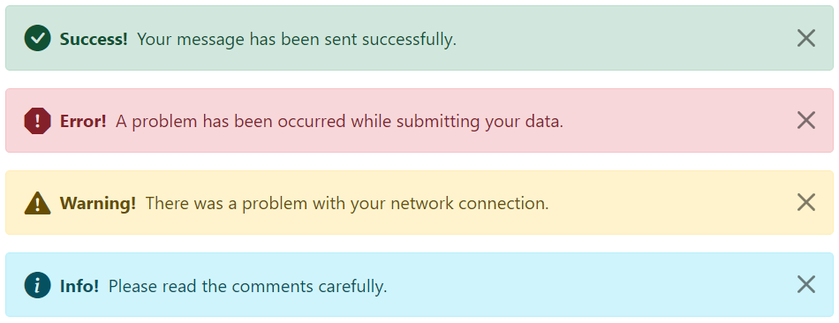

• What is a bootstrap card and how would you create one?

* A card is a flexible and extensible content container. It includes options for headers and footers, a wide variety of content, contextual background colors, and powerful display options. If you're familiar with Bootstrap 3, cards replace our old panels, wells, and thumbnails.

